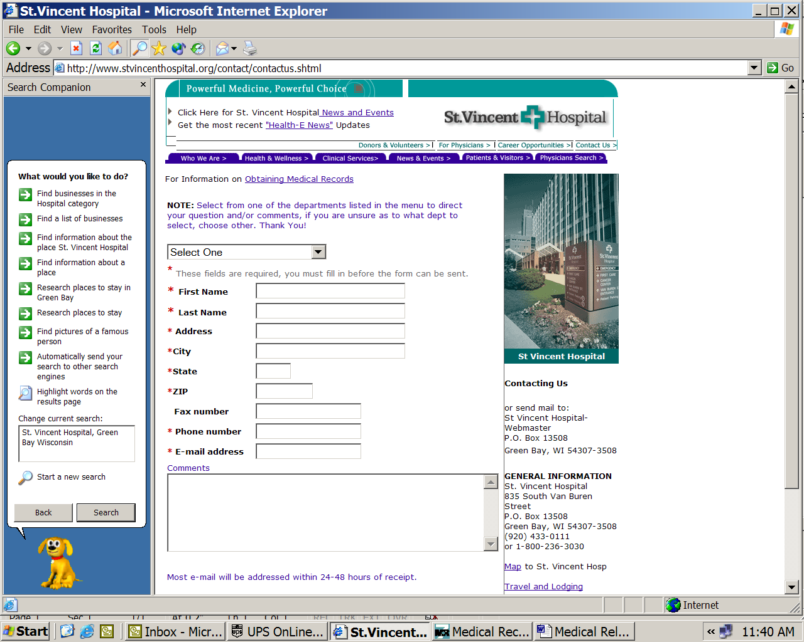
FOR OFFICE USE: MR# ____________________________
RECEIVED: ______________________
(date) (time)
P.O. Box 13508
Green Bay, WI 54307-3508
920-433-8413
AUTHORIZATION TO DISCLOSE
HEALTH INFORMATION (for Non-Research purposes)
1)
Karen Marcetti |  | XXX-XX-5076 |  | 12/22/1965
PATIENT’S NAME |  | SOCIAL SECURITY NUMBER |  | DATE OF BIRTH
2) AUTHORIZE ST. VINCENT HOSPITAL TO RELEASE TO:
Axiom Requisition Copy Service, 2869 Jolly Rd, Okemos, Michigan 48864
3) INFORMATION FROM MY HEALTH CARE RECORD FOR THE FOLLOWING DATE(S): From ____________To: __________
4) SPECIFIC INFORMATION TO BE DISCLOSED INCLUDES the following Specific Information which may include HIV test results and Mental Health counseling records:
Any and all records generated by ER visit dated 5/16/05; ER visit dated 5/17/05; Admission dated 5/17/05 to include just the typewritten reports as follows: Face Sheet, Discharge Summary, History & Physical, Operative Reports; Consultations and any other typewritten summaries pertaining to Karen Marcetti SSN: XXX-XX-5076, DOB: 12/22/1965.
5) PURPOSE OR NEED FOR DISCLOSURE OF INFORMATION: (check any that apply)
◻ Patient Request ◻ Continuing Care ☑ Legal ◻ Employer Use ◻ Insurance ◻ Other _________________
REDISCLOSURE NOTICE: I understand that information used or disclosed based on this authorization may possibly be re-disclosed by the recipient, and/or no longer be protected by Federal privacy standards.
YOUR RIGHTS WITH RESPECT TO THIS AUTHORIZATION:
Right to Inspect or Copy the Health Information to be Used or Disclosed – I understand that I have a right to inspect or receive a copy (with possible fee) of the health information I have authorized to be used or disclosed by this form. I may arrange to review or obtain copies of my health information by contacting St. Vincent Hospital Health Information Management Department at the phone number or address above. Right to Receive a Copy of This Authorization – I understand that if I agree to sign this authorization, I will be provided with a copy of it. Right to Refuse to Sign This Authorization – I understand that I am under no obligation to sign this form. Treatment, payment, enrollment or eligibility for benefits may not be based upon my decision to sign this authorization, (Exceptions: To provide care that is done solely for the purpose of creating information to release to another party, in which case care cannot be provided without authorizing disclosure. Authorization is needed to release information to payers for certain mental health services and HIV testing. If I refuse to sign the authorization form for this purpose, I understand I may be responsible for paying the entire bill for these services). Right to Revoke This Authorization – I understand that I may revoke this authorization. A description of how to revoke the authorization and any exceptions are included in St. Vincent Hospital’s Notice of Prvacy Practices. This notice is available at www.stvincenthospital.org or at the patient registration desk. HIV Test Results: HIV test results are protected under Wisconsin state statute 252.15 and may not be disclosed without written informed consent/authorization, except to persons or organizations that have been given access by state law. A list of those persons/organizations is available upon request.
6) EXPIRATION DATE: This authorization is good for 12 months or until (indicate date/event) ___________________________________.
________________________________________________________________________ ______________________________________
7) SIGNATURE of Patient or Legal Representative* 8) Date
*If Signed by Legal Representative – State Relationship to Patient _____________________________________________________________
________________________________________________________________________ ______________________________________
9) SIGNATURE of Witness 10) Date

A photocopy of this authorization will have the same force and effect as the original.
*Legal Representative means the parent; guardian; legal custodian of a minor patient; the guardian of a patient adjudged incompetent; a person authorized in writing by the patient; a health care agent designated under Chapter 155 if properly activated; a temporary guardian appointed by a court to consent to release of records; the spouse or personal representative of a deceased patient, or if no spouse survives a deceased patient (and no personal representative), an adult member of the deceased patient’s immediate family. A copy of the appointment as personal representative, guardian, or health care agent is required. (see Directive #100-08-008 “Valid Authorizations” for details)

Order No. 01-12345 - 003
For Office use: ◻ Picked Up ◻ Mailed ◻ Other: _______________________________________
Initials Date and Time Released: | Tracking #:

